Resetting an iPad
Without a Passcode
- Turn on iPad. If a passcode is required, see section on “Resetting with a Passcode” below
- Click on Settings
- Go to General and choose Reset
- Choose Erase All Content and Settings
- Confirm Erase, and this will clear all settings and data from iPad
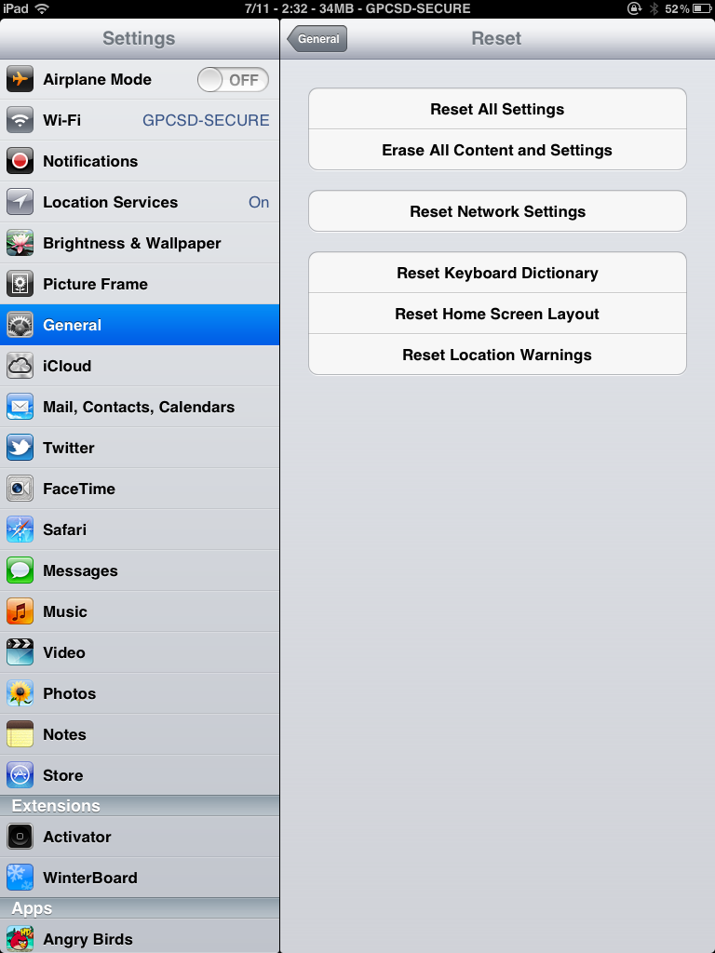

With a Passcode
- Turn on iPad. Be sure there is at least 20% charge on the iPad before starting this process
- Plug in connector cable to iPad and the USB end to the computer
- Cancel any dialog boxes that appear on the screen or in iTunes
- Press and hold the home button and the power button at the same time (up to 45 seconds)
- When the Apple logo appears, release the power button while holding the home button down
- You will see the following screen:
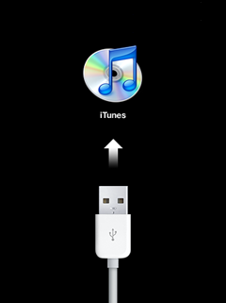

- iTunes will display the following message:
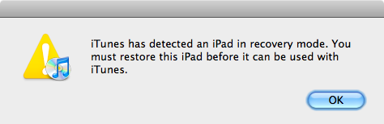
- Choose OK and then choose Restore
- You will be prompted for Restore and Update – click to continue and this will erase all data

http://support.apple.com/kb/ht4097

