iTunes-Purchasing and Gifting Apps
iTunes Gift Cards
Pull or scratch off the silver coating on the back of your gift card to reveal the 16 digit code
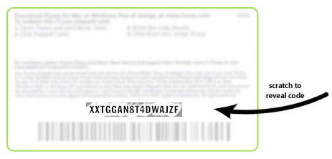
- Open iTunes
- Click Redeem under Quick Links on the right hand side
- Enter the code for the iTunes card in the field listed
- Click Redeem. You may be asked to sign in with your Apple ID
- Once done, you will see the balance of your account listed next to your Apple ID

iTunes Gifting
- Open iTunes and go to the AppStore
- Be sure you have selected iPad and not iPhone
- Find the item (free ones do not apply) and click the arrow to the right of the Buy button
- Choose Gift This App
- Once you have clicked Gift, you will be asked to sign in (if not done already) and will proceed to the Give a Gift page (see below)
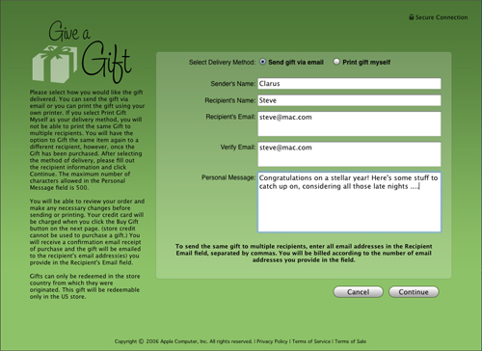
- Fill in the details listed above and choose continue. You will be asked to confirm the purchase. The gift will be sent to the person listed.

