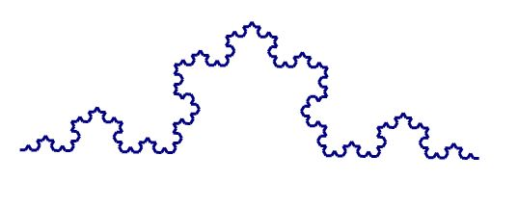

I had been puzzling over this problem task since it was first assigned. "Find a problem and play with it" seemed relatively straightforward when introduced but I began to over think it. I was looking for some deep, meaningful problem that could be solved by a stunning combination of math skills and technology. Sure to impress, perhaps, but not at all the intent of the assignment. It was one of those serendipitous combinations of events that helped refocus and ground me. Let me begin by explaining that over the past year, I've been making my way through any and all Richard Feynman videos. It's given me a great deal of pleasure to watch and listen to him... his intense curiosity, his need to question and wonder, the passion and excitement he exudes when he talks about learning. It's beautiful, inspiring, motivating… so recently, I also decided to start reading his books. A few weeks ago, I came across this poem from "Surely You're Joking, Mr. Feynman!". He included it at the bottom of one of the papers he wrote while a grad student at Princeton.
I wonder why. I wonder why.
I wonder why I wonder.
I wonder why I wonder why
I wonder why I wonder!
He spent his whole life wondering, questioning; he turned everything around him into an interesting problem that begged to be solved... from why rubber bands act the way they do to why trains stay on the track. And he didn't start out by looking for impressive problems that needed solving; he just spent a lot of time wondering about the simple things around him.
The day after I read his poem, we had math class. You were answering questions about the assignments and, just like Feynman, you referred to the problem portfolio in terms of questioning and wondering. That helped immensely as it was suddenly clear to me that all I had to do was relax and ‘wonder’. I immediately remembered my curiosity about fractals. Although I had missed the class on the dragon curve, Alicia had had more than enough enthusiasm about it to infect me, and then we worked with the Serpinski triangle. Researching for our presentation about aesthetics in math had led me to the Koch curve and I found myself wondering if it could also be made on Sketchpad. Hmm, a wondering, a questioning… I think I know what I have to do!
The problem of creating a Koch curve using Sketchpad became interesting right away. I quickly realized that I would need to create a line segment and divide it into thirds… easier said than done. I played and played and played until it didn’t feel like playing anymore. I watched tutorials, I googled fruitlessly, I selected every tab from every drop down menu – twice, I’m sure. I had moved deeply into the realm of frustration. At this point, I found myself thinking of students in my class. I always want my students to feel some frustration with a problem because it causes them to dig a little deeper, work a little harder. You know, the whole ‘zone of proximal development’ thing. But I never want them to slide so far into frustration that they begin to feel hopeless and worse, stupid. And yet, that’s where I found myself. With students in a classroom, I would intervene and offer a suggestion or a question or some kind of oblique help that would get them back on track and reengaged. I knew I needed to do that for myself now before giving up completely. So I called Alicia and Geri Anne. And Geri Anne had the answer… because she had had to ask you for help with the exact same question! You don’t know how much better that made me feel – knowing that someone else required the same support - which made me think of my students yet again. I need to ensure that I always teach and model when and how to get help, in order to ensure students view seeking help more as a useful strategy and less as a failing.
So Geri Anne helped me divide a line segment into thirds. I was a bit disappointed because she had to walk me through creating it step by step; she couldn’t just give hints. And that is one of the frustrations I sometimes feel with Sketchpad. There is no way I could have discovered using ‘dilate’ to divide a line segment on my own. It wasn’t an intuitive creation that I could stumble across. Others could, perhaps, and I wonder if anyone ever has? And unless I played with it frequently, I’d probably forget how to do it. Many of the building steps in Sketchpad require a logical recipe that has to be followed in order to achieve success. Yet this is balanced by the way it requires one to think about how to create shapes using circles, perpendicular lines, parallel lines… So, really, does it matter if I would have to directly teach my students how to perform the basic functions if it then allowed them to explore and create using what they already know and understand about geometry? I think not.
The advantage of using technology to create the Koch curve was so readily apparent. I found myself playing around with different iteration patterns to see what would happen if I changed the mapping order. Then Alicia came over and we started playing around with changing angles, which led to the creation of her own wondering and her own problem! I went on to create some beautiful designs and some truly unbeautiful ones! All I had to do was delete the mapping rules I created and make new ones. Imagine if I had been drawing the curve by hand… I would never have been willing to experiment because the time it would take to redraw would be discouraging. The task became engaging and meaningful as I began predicting what design would emerge, which is exactly what I would want my students to do. I can’t believe how many times I caught myself thinking, “I wonder what would happen if…?” This wouldn’t have happened using paper and pencil… at least not without a lot of perseverance.
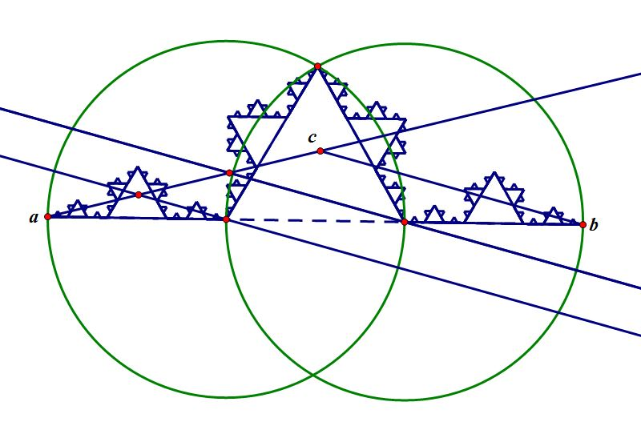
In a sense, the story of my time with this problem remains unfinished. Once I satisfied my curiosity about the Koch curve, I began wondering how to take what I had made and make the whole Koch snowflake out of it! It seemed like it should be a fairly straightforward process of translations, rotations, reflections… alas, it has not been that easy. But I’ve been enjoying the wondering process of figuring out how to do it… just haven’t been successful – yet!
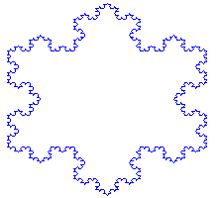

Doodling in Math Class: Dragon Dungeons Doodling in Math Class: Dragon Scales

