iPad/iPod Touch Deployment Guide
*Note – these instructions pertain to iOS 5.0 and above. Updated July 9-2012
iOS Setup (on the Macbook)
- On computer, open iTunes software.
- Plug in individual device to USB port.
- On the following screen, choose register later. Note – the registration pop up will show up several times. Choose register later until the option to never register appears. You will not see it again after that.
- On the license agreement, check the box to agree and select continue.

- On the “Set Up Your iPad” screen, type in the name of the device (located on back of unit.) Make sure that “automatically sync songs to my device” and “automatically sync songs to my device” are checked, and then choose done.

iOS Device Setup (on the device)
1. On the device, slide to unlock. 2. Enable Location Services, then click next. You will be asked to confirm, choose ok.

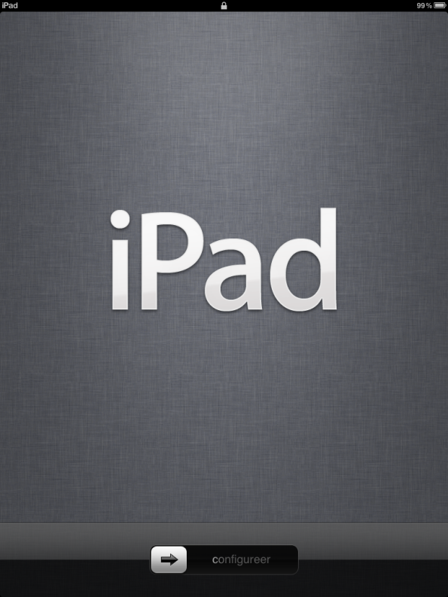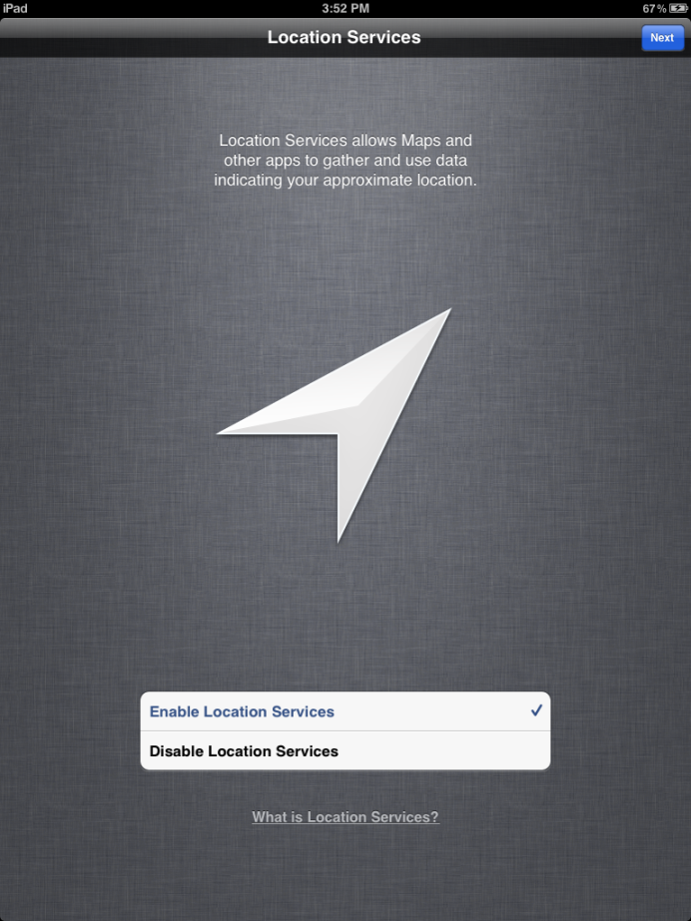

3. Wifi setup. Choose Next, then click continue 4. Agree to Terms and Conditions, then agree to continue without WiFi. again.
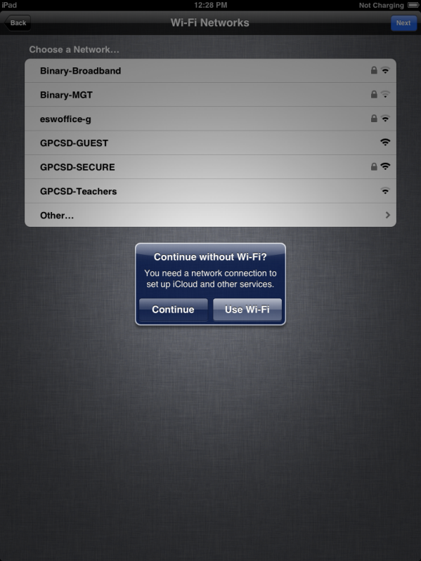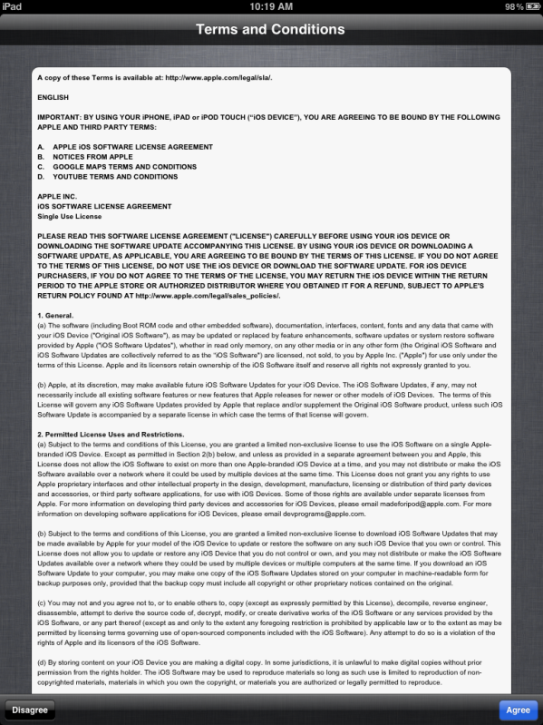

5. Choose Don’t Send, then Next. 6. Start Using iPad!

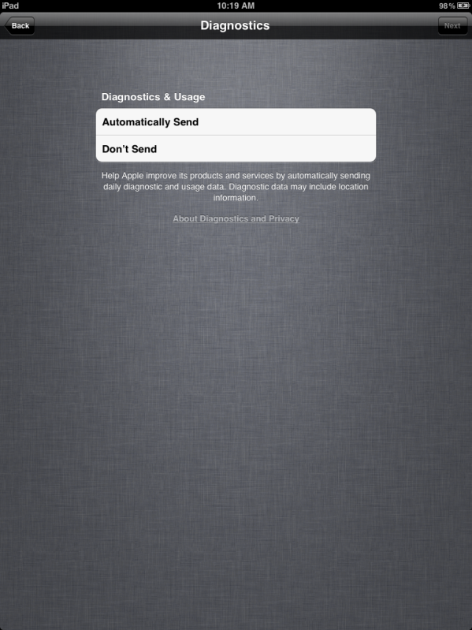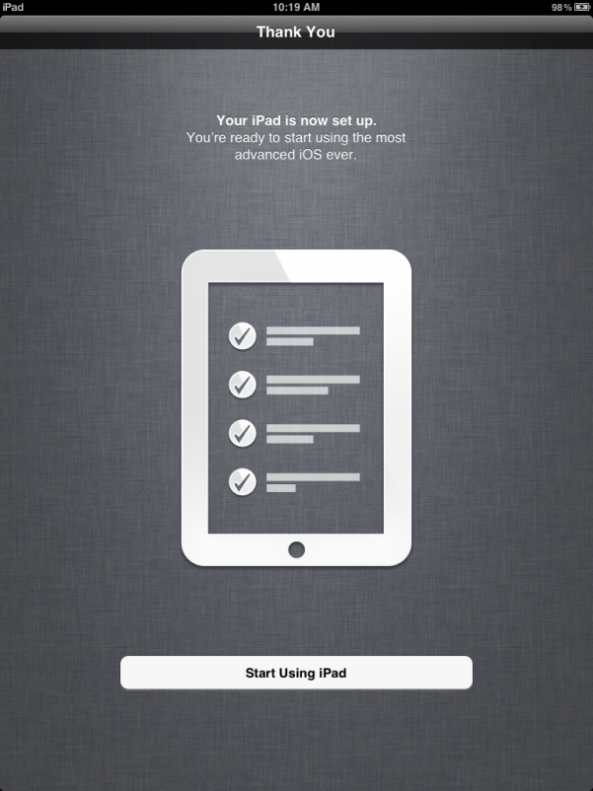

iPhone Configuration Utility (on the Macbook & iOS Device)

- Open the iPhone Configuration Utility Program. Ensure that an iOS device is plugged into the Macbook.

- Under Devices, click on the name of the iPad. Go to the Configuration Profiles tab and choose Install. On the iOS device, a popup will ask for you to install and confirm. The configuration profile will then be installed. Congratulations! You have completed your first iPad configuration!

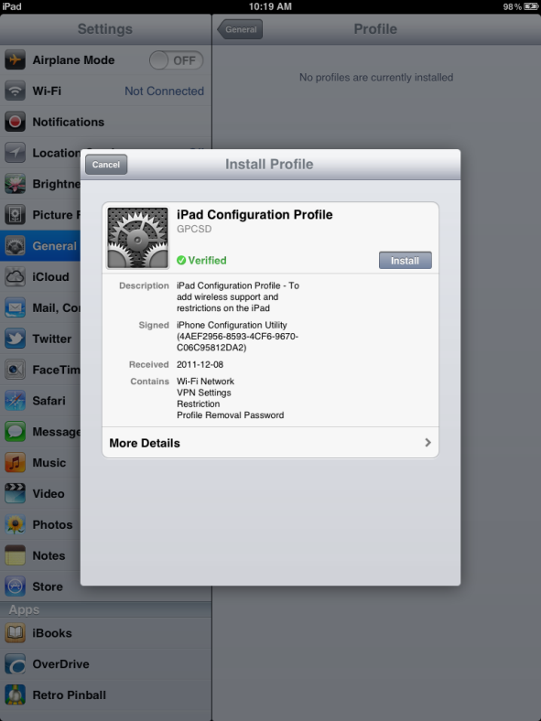

Notes
Naming Convention
At GPCSD, we chose the following:
XX-IPADX-ZZ
XX – This denotes the school name. SC=St. Clements, etc.
IPADX – This denotes the cart number. In the event of no cart, then IPAD is sufficient
ZZ – This denotes the number. The usual numbering scheme is 01 – whatever number is needed.
Here is an example. SC-IPAD1-04

Labelling
At GPCSD, we physically labeled the iPad’s to match the above naming convention. This produced a simpler way to determine if an iPad was missing from the cart.

