Google Docs Document Transfer
Step one is to login to Google Docs. Google Docs will offer a more simplified text editor versus the enhanced editing of Pages. For this discussion, we will rely on Google Docs as the main originator of this document. On the main screen, place a checkmark in the box to the left of the document that you want to send.
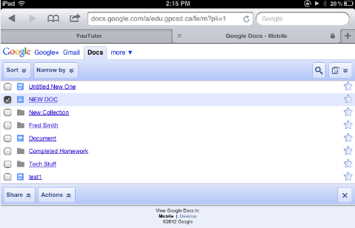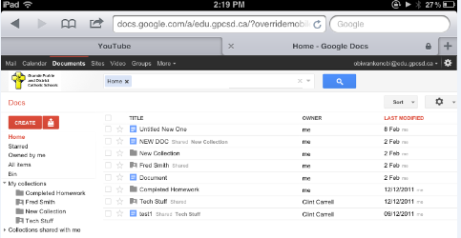
Mobile View Desktop View
In the mobile version, click the Share button and choose Email as an attachment. On the desktop view, click the More button and choose Share and Email as an attachment.
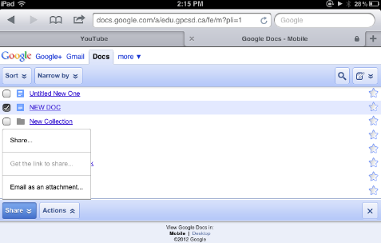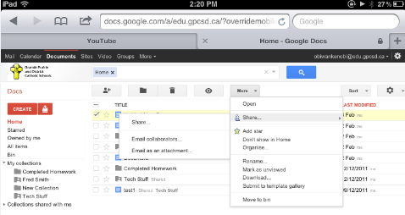
Mobile View Desktop View

Enter the email address (@gpcsd.ca), subject and any extra messages. Ideally, the subject should contain the student name and course/assignment
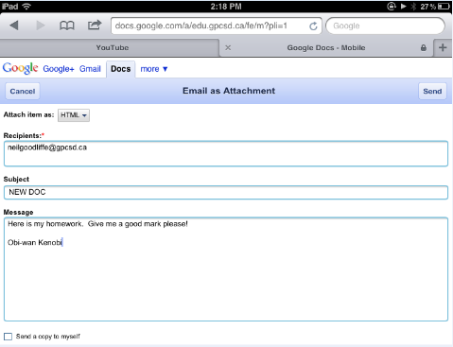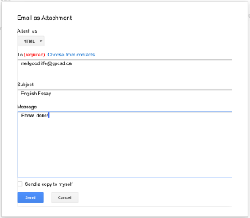
Mobile View Desktop View
Click Send, and the teacher or recipient will now have a copy that can be printed or reviewed.
Transfer from Pages
If the student used Pages for the document, it can be copied and pasted from Pages to Google Docs using the standard iPad copy/paste features. Enter the Google Docs word processing app and paste the test in. The previous instructions highlight how to email the document. Note – formatting may change, and any pictures will not show up at all.

