How to use the “GoodReader”

Document Transfer Application
- Start the “GoodReader” app on your iPhone / iPod touch / iPad.
- Open the “GoodReader's” WiFi-transfer page and keep it open the entire time while transferring your document(s). Please note the IP-address on this page.
This button brings up the WiFi-transfer page:
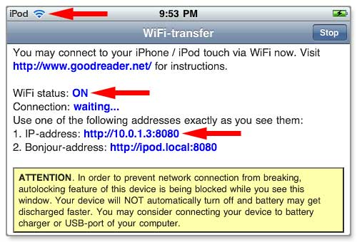
The important things here are:
- antenna logo at the top, it should indicate a strong WiFi signal (if you don't see this logo, then you're not connected to WiFi network)
- WiFi status: ON (if it's OFF, then you're not connected to WiFi network)
- IP-address (if you don't see it, then you're not connected to WiFi)
Don't be confused by the "Connection: not established" line. It's perfectly normal. It doesn't mean that there's any WiFi network problem, it simply means that nobody tried to access GoodReader yet. Once you initiate a file transfer from your computer, this line will immediately change to "Connection: established". This line is mainly for troubleshooting purposes - if you're experiencing problems with WiFi transfer, this line will be a good indication where to look for a problem.
Note the IP-address, you will use it to initiate a connection from your computer.
IMPORTANT: IP-addresses change from time to time, even if nothing else changes in your setup. So please don't assume that the IP-address is the same as it was during your last transfer session, check this address every time when connecting.

- You can connect to GoodReader from any web browser (like Internet Explorer, Safari, Firefox or any other). You will be able to upload files to your iPhone / iPod touch and create directories.

File transfer instructions:
- on your computer open a web browser (Internet Explorer, Safari, Firefox or any other)
- in the address field of your browser, enter your iPhone's IP-address taken from Step 2. Enter it exactly as you see it on GoodReader's WiFi-transfer page, with http:// and :8080 parts:
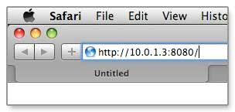
- please do NOT assume that the IP-address is the same as it was when you were connecting the last time - IP-addresses change periodically, check it every time when connecting
- the iPhone Connection page should open:
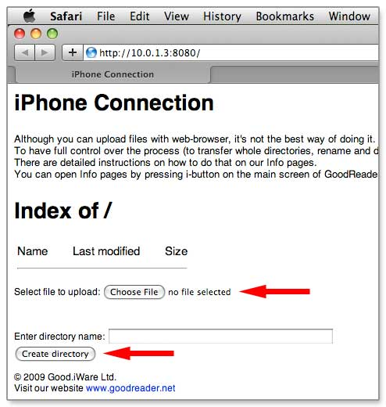
- find Select file to upload label and a button by it, use this button to select a file for further uploading, then press Upload selected file button (this button will appear as soon as you select a file to upload)
- use Create directory button to create a new directory
- click on a directory name to go inside that directory and to display its contents. All further file uploads will be made into a currently displayed directory.
- After all the transfer is completely done, close WiFi-transfer page.

