How To Create an iTunes Account

(without using a credit card)
Go to the iTunes Store
- Open iTunes and check to ensure that you are not logged in to any iTunes account.
- Navigate to the App Store.
- Ensure that you have picked the proper country.
- Find a free app and click on it to purchase it.
- You should now see a pop-up window. Click “Create Apple ID”.
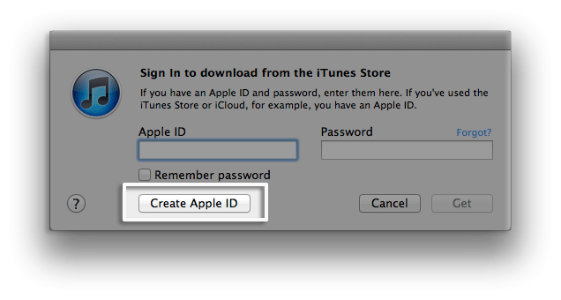
- Click “Continue” on the ‘Welcome to the iTunes Store’ screen.
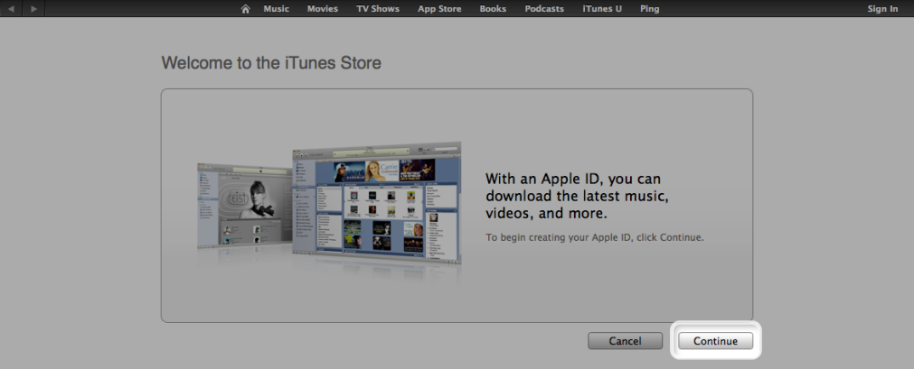
- Accept the “Terms and Conditions” and then click “Continue“.
- Enter your email address, create a new password and then create your security questions and enter your birth-date.
- Click “Continue”.
- Select “None” as the ‘Payment Type’.
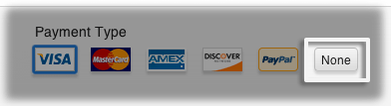
- Fill out the required name and address fields as required.

- Click “Done” on the ‘Verify Your Account’ screen and check your email for your verification email from the iTunes store.
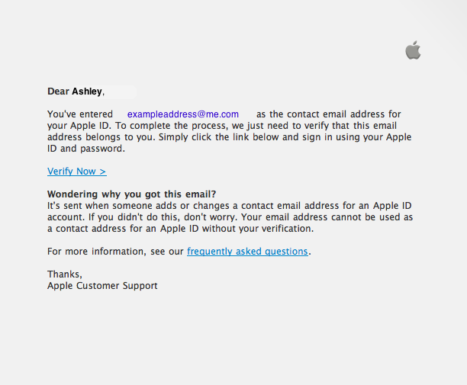
- Once you’ve clicked the link provided (or copied it and pasted it into your browser), you will be required to sign in with your new Apple ID, and to verify your account.
- Once you’ve signed in, you’ll see the screen below. Your new account is set up!
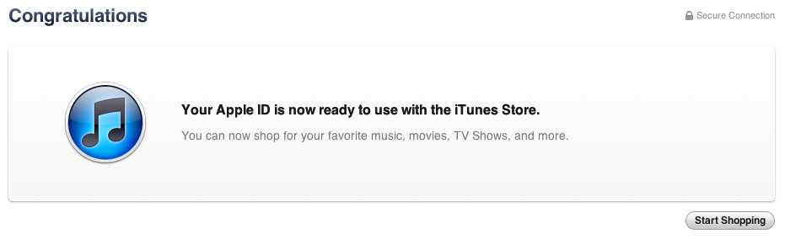
http://support.apple.com/kb/HT2534

